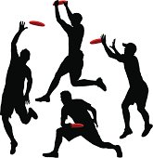
Authentic Assessment
Ultimate Frisbee
Name of Student | Application of Skills | Application of Strategy | Application of Personal/Social Responsibility | Total Score | Analysis
1.
2.
3.
4.
5.
6.
7.
8.
10.
11.
12.
13.
14.
15.
16.
17.
18.
19.
20.

Rating Scale:
11-12 Points = Excellent
8-10 Points = Good
5-7 Points = Satisfactory
3-4 Points = Fair

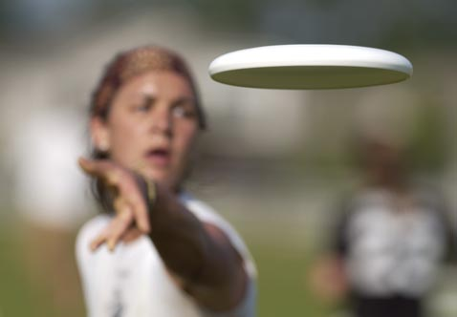
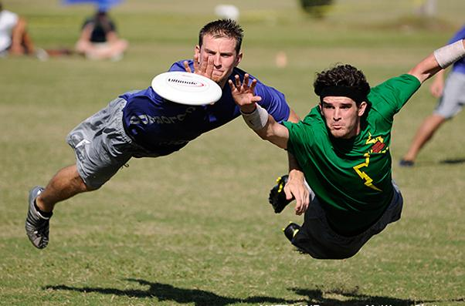

Application of Skills
4 Points | Student:  - is consistently able to catch the frisbee with one or two hands.  - consistently moves towards the frisbee while it is in flight.  - is consistently able to accurately throw the frisbee.  - has excellent technique and control.  - holds frisbee correctly.
3 Points | Student:  - is consistently able to catch the frisbee with two hands and occasionally one hand.  - consistently moves towards the frisbee while it is in flight.  - is consistently able to accurately throw the frisbee.  - has very good technique and control.  - holds frisbee correctly.
2 Points | Student:  - is usually able to accurately throw the frisbee.  - has good technique and control.  - holds frisbee correctly.  - is generally able to catch the frisbee with two hands.
1 Point | Student:  - is rarely able to accurately throw the frisbee.  - lacks technique and control.  - is occasionally able to catch the frisbee  - shows little or no fear and a genuine attempt to catch it.

Application of Strategy
4 Points | Student:  - consistently moves to open spaces on offense.  - consistently moves to cover their mark on defense.
3 Points | Student:  - consistently moves to open spaces on offense  - generally moves to cover their mark on defense.
2 Points | Student:  - sometimes moves to open spaces on offense  - does little on defense.
1 Point | Student  - rarely moves to help the team.

Application of Personal/Social Responsibility
4 Points | Student:  - consistently uses the whole team.  - often communicates with the team.  - displays an excellent sense of fair play.  - always follows the rules and never argues with the other students.
3 Points | Student:  - rarely uses the same teammates and often uses the whole team.  - sometimes communicates with the team.  - displays a very good sense of fair play.  - almost always follows the rules and rarely argues with other students.
2 Points | Student:  - generally uses the same teammates but occasionally uses the whole team.  - rarely communicates with the team.  - displays a good sense of fair play.  - usually follows the rules  - occasionally argues with other students, but overall, their progress is satisfactory.
1 Point | Student:  - often uses the same teammates.  - displays lack of fair play.  - sometimes follows rules and argues with other students.

Assessment Explanation

This assessment tool was designed for grades 9 – 12th and is for instructor use. This particular assessment was written for ultimate Frisbee, however could be modified for other sports or activities. The tool assess three areas of importance; application of skill, application of strategy and the students personal/ social responsibility. Each category will be scored/ given a point value that corresponds to the rubric. The points from each category will then be added together and that total will produce the students final score analysis/ grade. The results for this particular assessment are descriptive in nature rather than a letter grade, however, could easily be change to letter grades if need be. The analysis results we have choose (from best to worst) to use are as follows; 11- 12 points (pts) = excellent, 8- 10 (pts) = good, 5-7(pts) = satisfactory and 3-4 (pts) = fair.
To use this assessment tool the instructor will; 1st have the assessment sheet filled out for each individual (their name) they are assessing (multiple student per page). It is designed to assess multiple students at once; however they should be in the same game. 2nd A copy of the rubric (if you do not know the information by heart) for scoring purposes. Lastly, it will probably take one full game to assess each player on both teams (depending on team size). The instructor will observe the students that are being assessed and score them accordingly on the assessment sheet for each category. It is reasonable to think that because you can assess multiple students at once the average time per student assessment is about 1 minute. Therefore if you have 30 minutes of actual game time you would be able to assess 30 students in that time and so forth. The instructor can wait until the end of class or during their break to total the scores for grading. The only equipment needed to administer this assessment is the rubric, a writing utensil and the assessment sheet itself and the equipment used for ultimate Frisbee.
We decided to develop and use this type of assessment for a few different reasons, some of which have been mentioned above and will be explained in more detail below. We believe this tool is appropriate and of good quality for both those being assessed and whoever is doing the assessing. We also feel that this particular assessment tool can be versatile in what it is assessing.
First and foremost we feel this assessment tool is appropriate for the activity being assessed and will also assess appropriate content for the students age/grade level. The content in which we choose to assess we believe is valuable and pertinent information in regards to the subject being taught (ultimate Frisbee) and is easily observed. The assessment tool is of high quality for those reason along with being easy to use, the content being assessed within each category is easily discernible. What we mean is that it is easy to differentiate between a score of 4 or 3 and so on in each of the categories. We also believe that this assessment tool could be used by anyone and the same scores would be given, making it reliable. Further, the rubric is easy to translate to the assessment tool making it possible to assess many students in a short period of time. Once the scores are compiled they can be easily inputted to a computer program for grading if you are manually writing the assessment score down on paper. If already a using some form of technology to record the initial scores (I pad or I phone) it will be easy to keep up with your observation because it is just a number that needs to be recorded. We believe this assessment tool could be easily adapted for other sports/ activities by simply changing some of the vocabulary on the rubric to match what you are looking for and what activity it is you are teaching. Finally we feel this tool will allow us to easily assess our students in a game like situation quickly, easily and accurately.

Directions of the Assessment Process for Students
Explanation of the Set- Up of the Test
Today during class I am going to be assessing you during game play of Ultimate Frisbee. You will be assessed in three different areas. You will be assessed on your application of skills, application of strategy, and application of personal/ social responsibility. You are not required to do anything special, or different. Just play the game using the skills, strategies, and personal/ social responsibilities you have learned during the previous classes of this unit. Don't worry about me assessing you, just do the best you can and have fun.
Explanation of Scoring Rubric
As you can see on the scoring rubric, you will be assessed on the Application of Skills, the Application of Strategy, and the Application of Personal/ Social Responsibility. Each category has a 4, 3, 2, and 1 point scoring system. A score of 4 in a category is the highest score, and a 1 would be the low score.
Here is how each category will be graded.
Application of Skills
To score 4 points you will have to:
* consistently catch the Frisbee with one or two hands
* consistently move towards the Frisbee while it is in flight
* consistently and accurately throw the Frisbee
* have excellent technique and control
* hold the Frisbee correctly
To score 3 points you will have to:
* consistently catch the Frisbee with one or two hands
* consistently move towards the Frisbee while it is in flight
* consistently and accurately throw the Frisbee
* have very good technique and control
* hold the Frisbee correctly
To score 2 points you will:
* usually accurately throw the Frisbee
* have good technique and control
* hold Frisbee correctly
* generally catch the Frisbee
To score 1 point you will:
* rarely be able to accurately throw the Frisbee
* lack technique and control
* occasionally be able to catch the Frisbee
* show little or no fear and a genuine attempt to catch the Frisbee
Application of Strategy
To score 4 points you will
* consistently move to an open spaces on offense
* consistently move to cover your mark on defense
To score 3 points you will:
* consistently move to an open spaces on offense
* generally move to cover your mark on defense
To score 2 points you will:
* sometimes move to an open space on offense
* do little on defense
To score 1 point you will:
* rarely move to help your team
Application of Personal/ Social Responsibility
To score 4 points you will:
* consistently use the whole team
* communicate often with the team
* display excellent sense of fair play
* always follow the rules and never argue with other students
To score 3 points you will:
* rarely use the same teammates and often you the whole team
* communicate sometimes with the team
* display a very good sense of fair play
* almost always follow the rules and rarely argue with other students
To score 2 points you will:
* generally use the same teammates, but occasionally use the whole team
* rarely communicate with the team
* display a good sense of fair play
* usually follow the rules
* occasionally argue with other students, but overall, your progress is satisfactory
To score 1 point you will:
* often use the same teammates
* display a lack of fair play
* sometimes follow the rules and argue with other students
Again, don't worry about being assessed. Just do the best you can and have fun.
Explanation of how the Rubric will be used
Remember that the rubric will be used to assess you on your application of skills, application of strategy, and application of personal/ social responsibility. I will be doing the assessment during your game play today. I will be the one doing the scoring for your assessment today. Your total points will be calculated and you will be in one of the following four categories.
* 11- 12 points = Excellent
* 8- 10 points = Good
* 5- 7 points = Satisfactory
* 3- 4 points = Fair
This assessment will be included as part of your course grade, so try your best and have fun. Just play the game as you have been taught throughout the unit. Use the skills, strategies, and fair play techniques you have learned, and you will do fine.

Diagram of the Assessment Setting for Ultimate Frisbee

End
Zone
End
Zone

Evaluation area for Teacher

End
Zone
End
Zone

= Cones

References
Doolittle, S., Fay, T., & National Association for Sport and Physical Education. (2002). Authentic
assessment of physical activity for high school students. Oxon Hill, MD: National
Association for Sport and Physical Education.

Lund, J. L. (2000). Creating rubrics for physical education. Reston, VA: National Association for
Sport and Physical Education.

GYM CLASS Ultimate Frisbee | 5 LESSONS FOR YOU, THE TEACHER. (n.d.). Gym Class.
Retrieved March 12, 2013, from http://gymclassultimatefrisbee.com/

Ultimate Frisbee. (n.d.). Alden Central School District. Retrieved March 13, 2013, from
http://www.aldenschools.org/webpages/poeller/skill.cfm?subpage=1563627

