Badminton History and Fun facts

- Began 3000 years ago in China… sometimes using a foot instead of a racket.
- The first rules were adopted by the English Badminton Association in 1905.
- Former names were Poona in India and Battledore in China
- The game was brought to America in the 1890’s
- Badminton came from the summer home of the Duke of Glouchester in England
- Tem championships for men- Thomas Cup
- Team championships for women- Uber Cup
- Became an Olympic sport in 1992
- It is the worlds fastest racket sport. A shuttle can travel approximately 200 mph.
- Best shuttles are made of feathers. These come from the left win of a goose.
- 16 feathers make a shuttle
- Shuttles are also made of plastic and nylon
- Shuttlecocks may be purchased in slow, medium or fast play
- Largest shuttle is in Kansas City 18 feet tall and 5000 pounds
- Main countries- China, Indonesia, Malaysia
- During a typical match lasting 45 minutes, the player can make at least 350 changes of direction and strike the shuttle about 400 times.

Benefits of playing:
- By playing badminton you can burn .214 calories per minute per pound of your body weight. So, for example, if you weigh 120 pounds and you play badminton at a vigorous pace of 30 minutes, you will burn 770.4 calories (.214 x 120 x 30).
- Badminton is a lifelong sport. You can play it when you are 5 or 75!
- You only need one other person in order to play.
- A badminton player may cover more than one mile in a single match.
- It’s fun!
- The rules are simple.
- Strengthen the wrist, arms and legs.
- Build endurance
- Improve agility and coordination.
- Reduce tension and Improve social relationships

Scoring:
Scoring System
- A match consists of the best of 3 games of 21 points.
- Every time there is a serve – there is a point scored.
- The side winning a rally adds a point to its score.
- At 20 all, the side which gains a 2 point lead first, wins that game.
- At 29 all, the side scoring the 30th point, wins that game.
- The side winning a game serves first in the next game.
Singles
- At the beginning of the game (0-0) and when the server’s score is even, the server serves from the right service court. When the server’s score is odd, the server serves from the left service court.
- If the server wins a rally, the server scores a point and then serves again from the alternate service court.
- If the receiver wins a rally, the receiver scores a point and becomes the new server. They serve from the appropriate service court – left if their score is odd, and right if it is even.
Doubles
- A side has only one ‘service’.
- The service passes consecutively to the players as shown in the diagram.
- At the beginning of the game and when the score is even, the server serves from the right service court. When it is odd, the server serves from the left court.
- If the serving side wins a rally, the serving side scores a point and the same server serves again from the alternate service court.
- If the receiving side wins a rally, the receiving side scores a point. The receiving side becomes the new serving side.
- The players do not change their respective service courts until they win a point when their side is serving.
- If the serving team loses the serve, it is the opponents serve.
If players commit an error in the service court, the error is corrected when the mistake is discovered.
Other Game Play Information
- Server calls score, server’s score first.
- Toss to decide serve and/or side
- Hits net it is good and on line is in
- The racket may not touch the net.
- Follow through may go over the net but not touch the net.
- Server must stand inside the service court, serve diagonally
- The shuttle must be contacted entirely below the waist when it is contacted on a serve.
- The serve may hit the net and still be in play.
- A serve is lost if he/she misses the shuttle.
- Server serves until he/she loses a rally rotating right and left
- Must keep feet on ground during serving
- May not “carry” a shuttle

Court
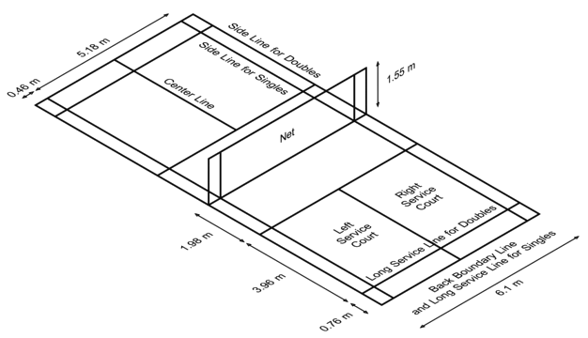

Serving Information

Course of action / Explanation | Score | Service from Service Court | Server & Receiver | Winner of the rally

 | Love All | Right Service Court. Being the score of the serving side is even. | A serves to C A and C are the initial server and receiver. | A & B | 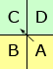
A & B win a point. A & B will change service courts. A serves again from Left service court. C & D will stay in the same service courts. | 1-0 | Left Service Court. Being the score of the serving side is odd | A serves to D | C & D | 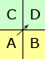
C & D win a point and also right to serve. Nobody will change their respective service courts. | 1-1 | Left Service Court. Being the score of the serving side is odd. | D serves to A. | A & B | 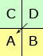
A & B win a point and also right to serve. Nobody will change their respective service courts. | 2-1 | Right Service Court. Being the score of the serving side is even. | B serves to C | C & D | 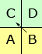
C & D win a point and also right to serve. Nobody will change their respective service courts. | 2-2 | Right Service Court. Being the score of the serving side is even. | C serves to B | C & D | 