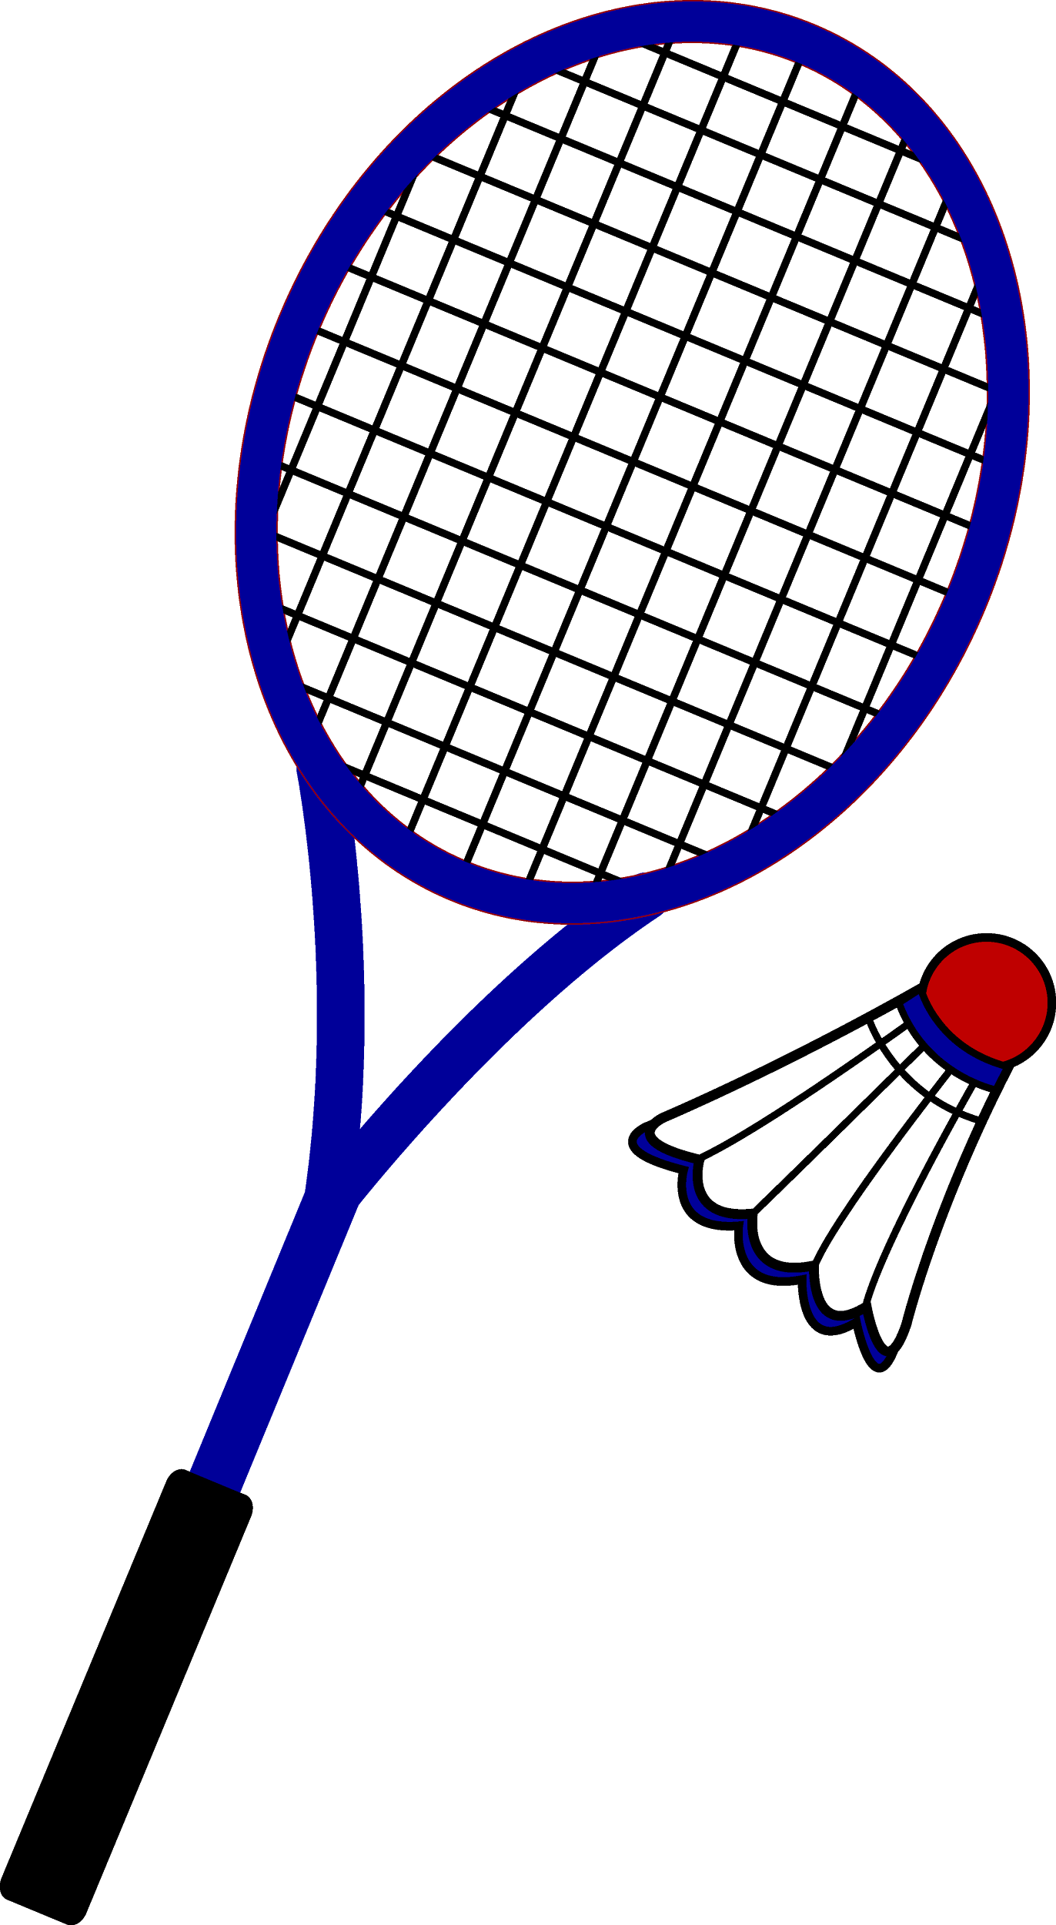Before we begin, tell me how you feel about your ability to...
Skill / Concept | Novice | Intermediate | Advanced | Superior
Make contact with the birdie
Serve the birdie
Execute a drop shot
Hit the birdie to open space
Execute a drive shot
Smash the birdie
Establish defensive position
Rules of the game

NOW THAT WE HAVE HAD TIME TO PRACTICE HOW DO YOU FEEL…

One skill or concept you have improved upon:_____________________________________

How would you describe your proficiency in this skill when it was first introduced? (the first opportunity you had to practice it)

How do you feel you have improved in your ability to either execute the skill, or if more practice is needed, better understand HOW to execute the skill?

What element of the skill or concept is your strongest?

What element of the skill or concept would you like to see the most improvement in?

