Disc Games 2016
Lesson Focus: Maintaining possession of the disc.

National PE Standards:

Standard 1-Demonstrates competency in a variety of motor skills and movement patterns.

Standard 2- Applies knowledge of concepts, principles, strategies and tactics related to movement and performance.

Standard 3 - Demonstrates the knowledge and skills to achieve and maintain a health-enhancing level of physical activity and fitness.

Standard 4 - Exhibits responsible personal and social behavior that respects self and others.

Standard 5 - Recognizes the value of physical activity for health, enjoyment, challenge, self-expression and/or social interaction.

Session Outcomes:
1. Participants will be able to demonstrate a standards-based lesson utilizing teaching games for understanding.
2. Participants will be able to demonstrate fitness activities, which may be used to introduce a skill.
3. Participants will be able to participate in activities with a diverse group and utilize problem-solving skills.
Embedded outcomes:
- Responds appropriately to participants’ ethical and unethical behavior during physical activity by using rules and guidelines for resolving conflicts. (S4.M4.8)
- Cooperates with multiple classmates on problem-solving initiatives. (S4.M5.8

Teambuilding Activity: Zoom, Erk Group Juggle

Objectives:
Equipment: a variety of soft objects (about 5 for per group); (groups 12-15)
Have the group or groups form a circle. Leader places objects beside them.
Presenter asks: (one of the questions below or any that pertain to your group)

Teachers: What are your goals for improving your physical education program?
Students: What do you need to do in order to be successful this school year?

*Each thing they name represents the objects. These things are important and you should value them. In this activity we need to take care of those things.

The leader begins the game by having everyone put both hands clasped in front of their body. Tell the group that you are going to throw the ball to someone. Before they throw the ball ask, “Name of catcher”, please catch the ball” and the receiver responds “thanks… name of thrower”. Once you’ve received the ball put your hands behind your back. And throw it to another person who hasn’t received the ball. Continue this until everyone in the circle has received the ball and then the ball is thrown back to the leader. Each person should remember who he or she threw the ball to and received the ball from. Now repeat throwing the ball around the same pattern (receiving the ball from the same person you did the first time and throwing the ball to the same person you did the first time using the same please and thank you pattern.)
Once the pattern is well established and the group gets comfortable throwing the object then discuss: What are other things they have to do? (such as… homework, football practice, clean their room… or lesson plans, feed the kids, church choir…..)
Now when the leader yells, “add” we are going to add another object until all are going around the circle.
When balls begin dropping stop and emphasize that this is what happens when we get too much going on in our lives. Presenter asks: What do we need to do in order to be successful in this task? Try it again this time with more focus, call the names, pay attention, be patient, work together….
Variation: If the leader yells “Erk” the direction of travel reverses for all the balls (you now receive the ball from the person you were throwing to) If the leader yells “Zoom” everyone must change their location in the circle, but continue throwing to the same person. It will not take long for things to get crazy. Watch what happens to “please and thank you” communications.

Decoder Activity
(See folder on website)
AEROBIC NUMBERS (Don Puckett)

- Need a set of cards (regular or UNO)
- Minimum four cards of each number.
- Each team will be given a number.
- Place the number cards face down about 60 to 80 feet away.
- On the signal one person from each team will run to the numbers, turn ONE up and look at it.
- If the number matches the number of his/her group they take it back to their line.
- If it does not match they turn it face down and return to their line, and the next person takes a turn.
- This continues until the team finds all four of the number cards that match their number.
- Having a point where the returning player crosses that allows the next person to start helps to speed up the activity and cuts down on just sitting and waiting.
Instant Activity
- Get a jersey, disc and partner and move to an open space in your home grid.
- Practice passing and catching the disc with one and two handed catches.
Warm-Up
Exercise Specialist: Team warm-ups using at least 2 health related components.
Ultimate Frisbee Sprints:

• Students work in pairs with one disc and three cones per pair
• Place three cones 10 meters apart and 10 meters from the goal line
• Pairs line up along the front of the goal line with one player holding the disc
• On a signal, the second player (runner) must sprint to the first cone, turn around, receive the pass from his or her partner, plant, and pass it back
•The runner must then run back to goal line and repeat the same thing to the second and third cones.
• Partners switch positions.

Speedway: Working in Grids - Home Courts
- With a partner. Stand 10-15 feet apart.
- Throw the disc to a partner for time. Count the number of throws.
- Each dropped disc must start over.
- Variation: The player without the disc is performing line jumps
Musical Frisbee
- Work in small groups. Two offenses vs. two on defense.
- One of the defenders must be a marker.
- Offense must try to keep possession of the Frisbee. (5 second count)
- The team that has possession when you stop the music scores a point.
Speedy Frisbee-Volleyball
Equipment: 2 Frisbees and a tape or rope
- Divide the class into teams of four – six students. Two teams compete against each other.
- Each team should have one Frisbee.
- The back right person from each team has the Frisbee. They toss the Frisbee across the net at the same time.
- The object is to toss the Frisbee back and forth as quickly as possible. If one is dropped or goes out of play leave it until both are out of play.
- Rotate positions with each point.
- The scoring is one point per Frisbee. Potentially, a team could get two points per serve.

Hula Hut Game for Points
Teams run to cone. Perform the exercise. Retrieve one hoop. Go until you get 6 hoops. Make a hula hut. Throw disc at the huts. Go back make another hut and do the same. Teams make three huts.
Give & Go Drill
- One student throws disc to a student who cuts downfield to receive a pass in return.
- Students repeat the pass and run, then switch lines at the end zone.
- Switch sides and repeat the drill Emphasize the “no traveling” rule
Short or Deep
- Combine two teams. Make three lines. Throwing, Defense and Receiving.
- Receiver starts running deep. Defender covers. Suddenly stop running and cut in towards the disc and you should leave the defense behind. Try until open.

90-second drill

- Stand approximately 10 meters apart diagonally.
- Player Blue should have the disc.
- Player Red should first run simulating a cut to area A.
- Player Blue should throw the disc to area A so that Player Red can run onto it and catch it.
- Player Red should then throw the disc back to Player Blue and jog back to his/ her starting position.
- Player Red should immediately run to area B simulating a cut to which player A should throw the disc for Player B to catch.
- Player Red should then throw the disc back to player Blue and jog back to his/her starting position.
- Repeat for 90 seconds.
- Goal is to work on timing of the throw.

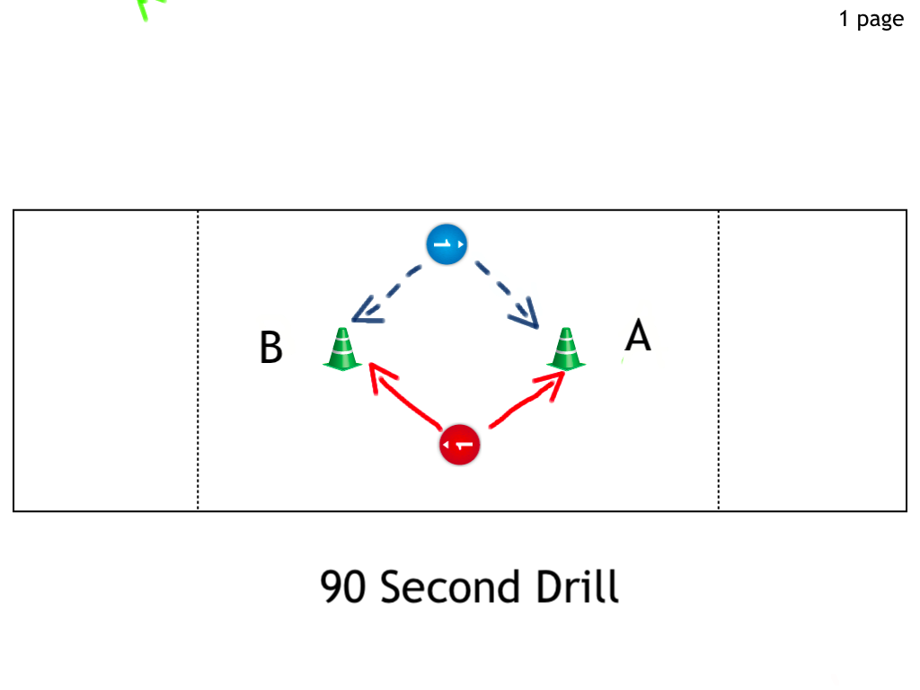

2-on-2 Cone Frisbee:

• Students work in pairs with one disc per game and one cone per pair
• Each pair can place their cone anywhere on the field
• Encourage cones to be placed 10–15 meters from each other
• The goal of the game is to hit the other team’s cone with the disc
• Players can only advance the disc by passing—no running with the disc, no contact
• When a turnover is made the disc goes to the other team
• When a team scores, the disc goes to the other team

Catch Game in Grids (Frog/Alligator Frenzy)
- The object is to complete 5 consecutive passes without dropping the disc or having it intercepted.
- If 5 catches are completed, 1 point is awarded and the other group takes the disc.
- If the disc is intercepted or deflected, the defense takes possession at that spot.
- Count your catches out loud. May hold 5 seconds.
- May not move when in possession of the disc.
2 vs. 1 Practice

- Each group will have a defender and two attackers who will try to maintain possession of the disc using the backhand throws.
- Three players. Receiver is moving
- Thrower chooses when to throw. (Use pivot/Fake) Do not throw over the marker; throw around them. Marker must give the thrower space.
- Switch positions. After a few throws.
Variation: Add a stall count and also add a marker on the receiver.
Peer Assessment *Captain assesses their team on passes and catches.
- Two teams join together. Place each group at a poly spot/cone facing each other. Team A XXXXXX xxxxxxx Team B
(Captain) (Captain)
- Team A pass to team B. Team A will then go to the back of the line of Team B.
- Team B will catch the disc using a two handed catch. Then pass to Team A and go behind. Add high and low one-handed catches.

Team Drill
Assessment sheet teams draw a drill to improve throws to a moving target.
Mini Ultimate:
Each team will setup their grid and break up into a 3v3- This will be a small game of keep away where you are trying to move the Frisbee to the other end but you cannot move when you have the Frisbee in your hand
Variation: 4 complete passes before scoring. CC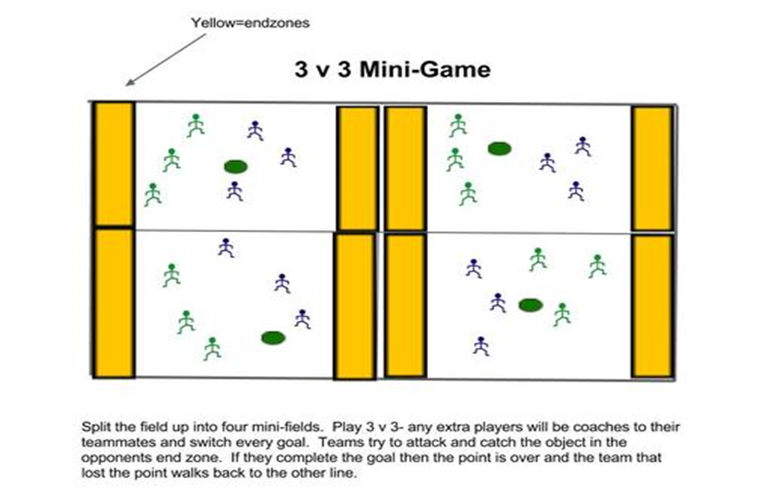
Box Game: Competitive

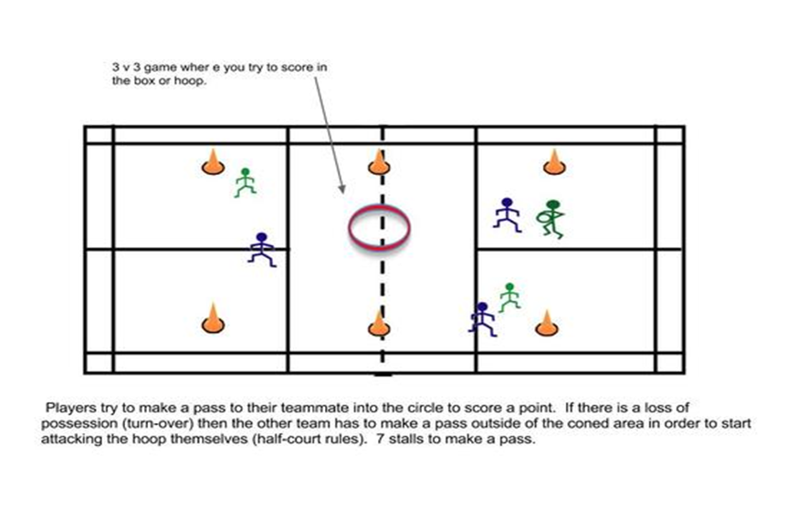

Team Points Activity 6-way Frisbee
- 6 teams, 12 hula-hoops and 6 colored discs per team.
- The object of the game is to get your team’s 6 disc in your hoop.
- All disc start in your middle hula-hoop.
- Only one disc played at a time.
- A disc must be out of play or tossed into the goal before another of the team’s disc can be put into play.
- Defense is allowed the second game. No contact and defensive players must remain an arms distance away from the opposing player.
- A dropped disc must be returned to the center of the playing area and tossed back out into play again.
- Players may not run with the disc.
- Disc that is intercepted by an opposing team must be returned to their hula-hoop in the center of the gym. The game is over when all discs have been thrown into the goal.
Debriefing:
1. How can we be more successful as a team?
2. What can we do to get our disc home quicker?
Throw-and-Go Drill
- Players make two lines single file facing each other. 15 yards apart.
- First player in line A and B do not have a disc, but the next four players do.
- First person in line A runs hard at a 45-degree angle toward line B. He is running to receive a backhand. He makes the catch and runs to the back of line B handing the disc to the next person in line who needs a disc.
- The drill continues in this manner with each player having at least 10 chances to throw and catch a backhand.
- Variations: Throwers use a pivot and then a pump fake to the opposite side before making the proper throw.
- Receivers catch with only one hand or their non-dominant hand.
- Add a marker to both lines to increase the difficulty of the throws, making the drill even more realistic.

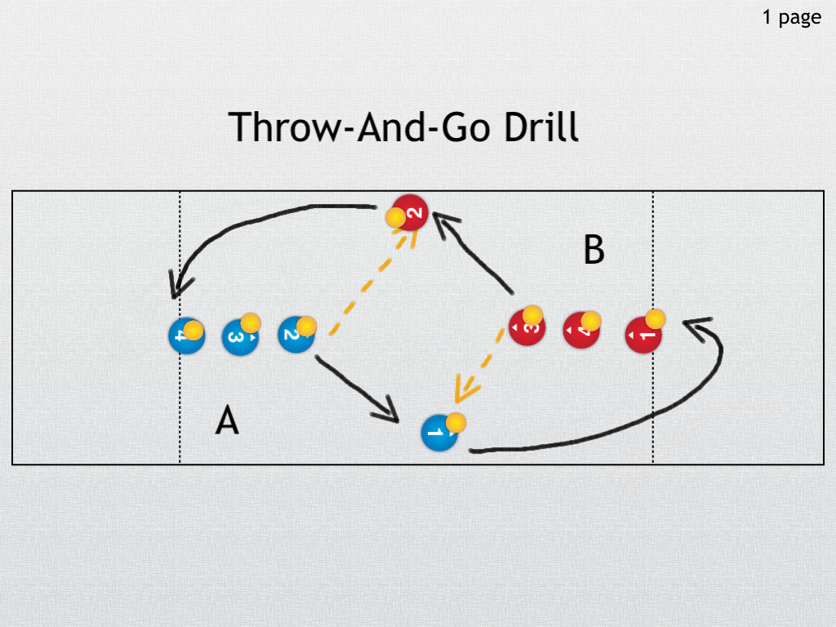

Ultimate Fish Ball game
Focus: Work on pivots and catches without moving with the ball.
- Two teams face each other. One team begins play in their end zone.
- Pass the fish to teammates. May not run in possession off the fish.
- Only one defender on the person with the fish.
- To score a team must catch the fish across the goal line.
- Defense must be one foot away.
- Dropped fish: The last person to touch the fish goes to the other team.
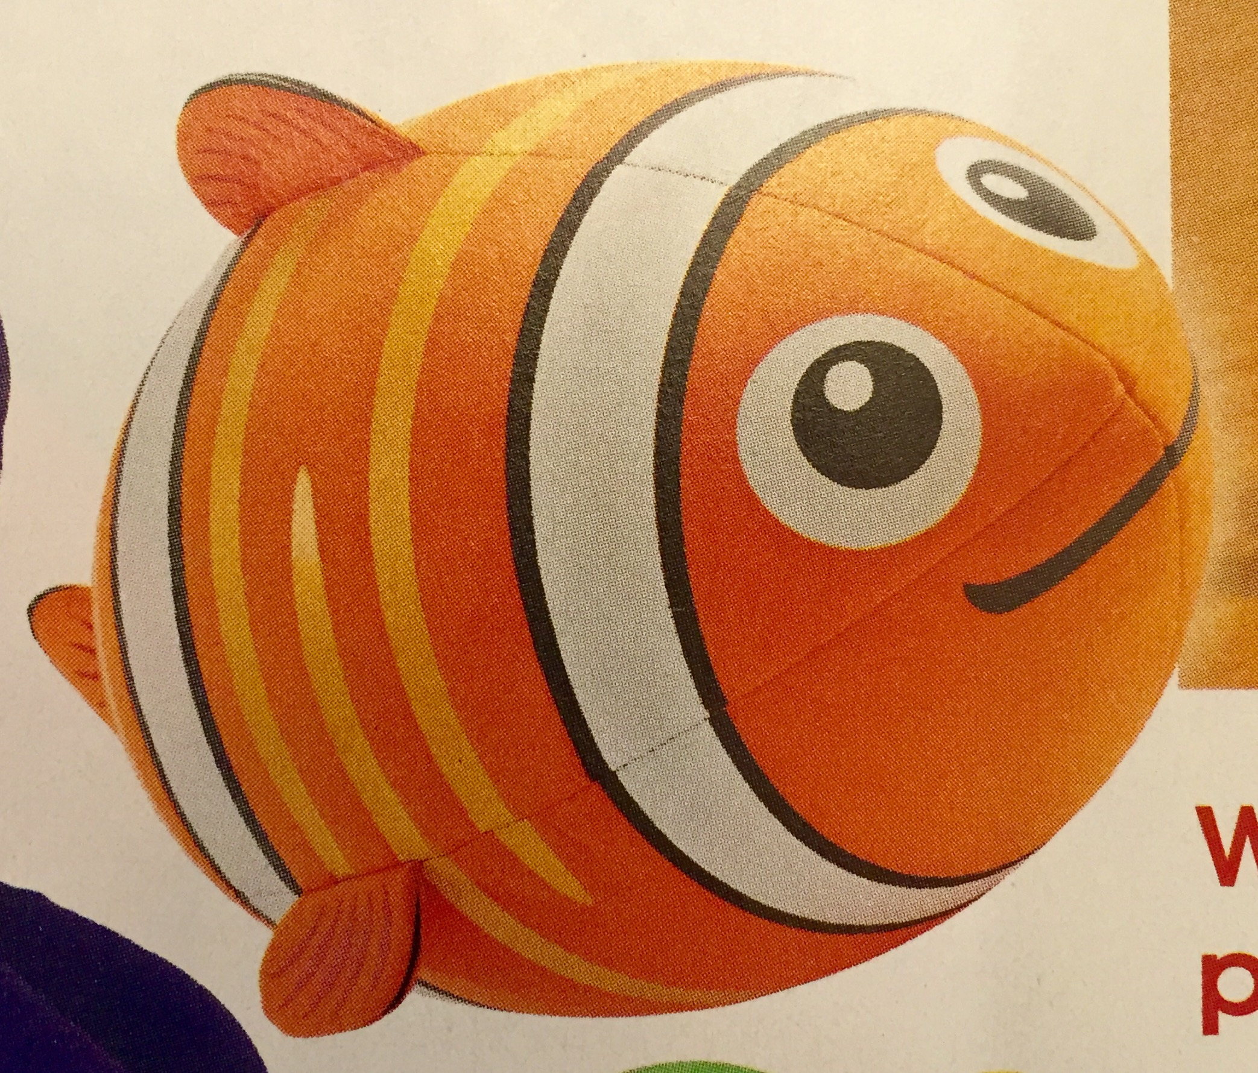

Round Robin Tournament: Ultimate Play regular game of Ultimate adding the rule of 5 consecutive passes in a row = 1 point.
Rock Paper Scissors:

Students face off in a one on one game. Winner raises their hand and actively finds another competitor while the non-winner becomes their FAN CLUB. After another face off, the one you are rooting for could change.

Exit Ticket: Fill out Invasion Game Self-Assessment. Place in team folder.
Resources:
www.usaultimate.org
www.pecentral.org
Rink. Judith E. Teaching Physical Education for Learning.
NASPE, Physical Activity & Sport for the Secondary School Student
Manson, Mara & Herman, Ariela, NASPE 2012, Smart PE Moves
Baccarini, Michael & Booth, Tina Essential Ultimate
Instructional Models Handbook PIPELINE 201
Other games or drills

Hoop Frisbee:
Use one disc per game. Divide the field into four quadrants with two hoops in each.
Divide the students into eight teams of four and assign two teams to each quadrant.
Within each quadrant, students will play 4-on-4 mini games, scoring by catching the disc in the hoop. The play always begins with one of the teams having possession in their hoop.
Encourage players to play hard defense and use the stack strategy to get open. Remind students to always have a dump. When you blow the whistle, teams rotate based on how they did. If they won, they move one quadrant counter-clockwise (if they won and are in quadrant 1, they stay there). If they lose, they move one quadrant clockwise (if they lose and are in quadrant four, they stay there). Continue the mini games until you signal stop.

Zone Frisbee- (PE Central)

Form of Ultimate Frisbee played with 3 zones and 3 Frisbees.
- There will be two teams of 15 students on each field.
- The teams will be divided so that five players on each team are in each of the zones.
- There is a defensive zone, middle zone, and offensive zone for each team.
- The field is 55 yards long making each zone 15 yards with two 5 yards scoring zones. The same rules of not being able to move when they have the Frisbee and only having 10 seconds to throw the Frisbee still apply.
- The defense must also be at least two yards away form the thrower.
- If the Frisbee hits the ground, it is a turnover at the spot where the Frisbee touched the ground.
- If the Frisbee is caught in the scoring zone by the offense and they score, the defensive team starts play toward their goal line at the offensive goal line.
- The players on offense of each team keep track of how many goals they have scored.

Passing Drill:

Divide teams into three versus three in a 20 by 20 playing area.
Each team attempts to pass the disc to their teammates as many times as possible without being intercepted.
Each successful pass counts as one point. Switch roles when the disc is intercepted.
Play for a certain amount of time.

Circle Passing -
- Form two evenly spaced circles.
- 2 students go to the middle with one disc.
- Student passing the disc follows the disc and prepares for future receiving this pass and move rotation goes all around the circle with new players coming to the middle each time to receive the disc.
- Variation: Competition can be timed on how fast the disc is rotated through the whole group back to the starting point or between two circles to see who can get through it the fastest.
- Two more go to the middle (4 total) and same passing pattern is used again with 2 discs being used at one time.
- Advanced- Add another disc with this being the 3rd disc (6 players in the middle or even 4 disc, 8 players in the middle).

Four Team Ultimate Frisbee

Four teams play at 4 goals on a square field. (North, South, East and West)
Each team attempts to score in their own end zone as well as defending the other three end zones.
Variation: Use more than one Frisbee.

Frisbee Tag: Depending on the group size up to 4 people will be the taggers. The rest of the class will get one Frisbee per student. If a tagger tags a student that student is “frozen” and they have to hold their Frisbee above their head creating a circle. To unfreeze the player, one of the other students must throw their Frisbee through the created circle by the “frozen” student.

- 3 students with pinnies (taggers)
- 3 students with Frisbees (savers)
- The rest of the students are escapers
- Half court
- If tagged the students have to perform high knees until the Frisbee is thrown to them and then they become the savers.
- The savers have to throw the Frisbee from 10 feet away
- They can throw with either hand and catch different ways.
- Start out walking, and then progress to jogging

Task: Each group of six will setup their rectangle and break up into a 3v3- This will be a small game of keep away where you are trying to move the Frisbee to the other end but you cannot move when you have the Frisbee in your hand- you must have 4 complete passes before scoring

Excellent Web Resource:
Victoria Youth Ultimate: https://t.co/ySPrHEDcX7

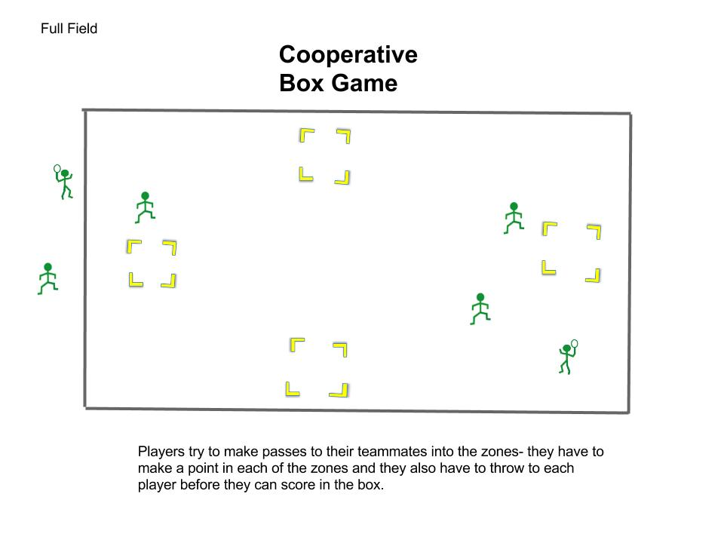
Variation:

Add a defender. This game should start off being 3 v 1 so that the defense has to work hard and try to choose to take away the biggest threat. The offense should work to move the disc away from the defender to throw to the open players and then attack the box. Then slowly add in extra defenders

