OPEN Curriculum
Free, Customizable, High-Quality
For more information:
Contact: Charla Krahnke
Email: charlaphysed@gmail.com Twitter: @ncpe4life

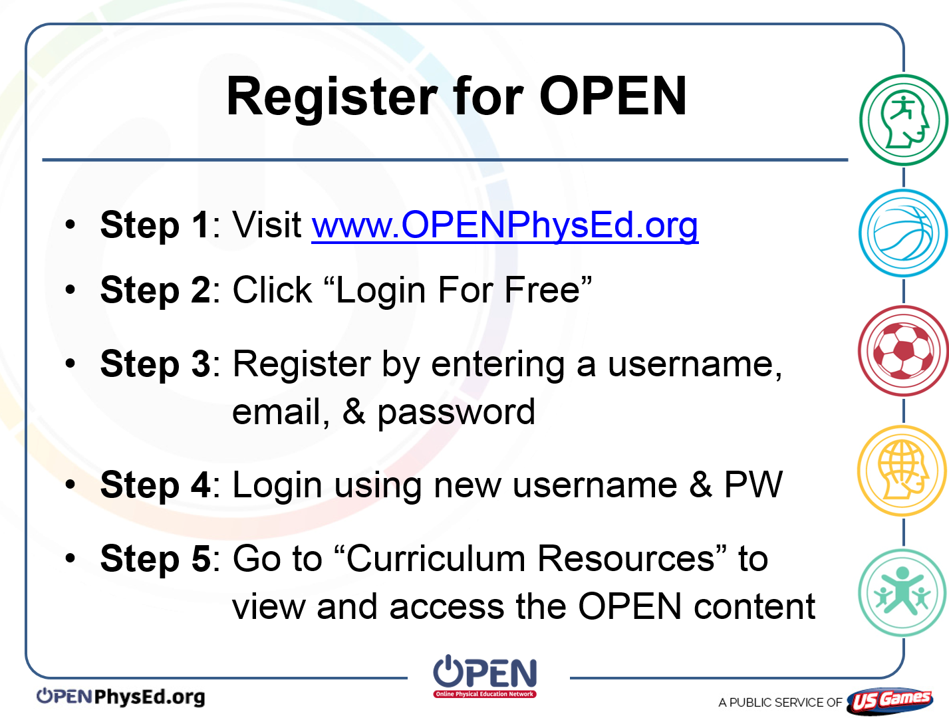

OPEN is a high-quality curriculum resource aligned to the SHAPE America Standards and Outcomes. OPEN is free and documents are customizable in MS Word or PDF formats.

OPEN Modules Include:
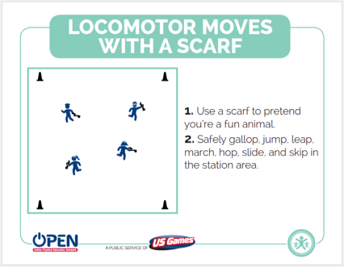
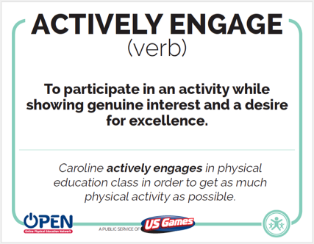
Activity Plans
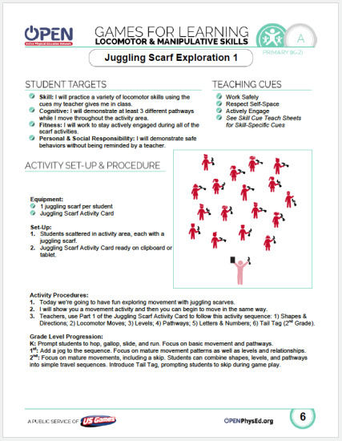

Academic Language Cards
Station Cards
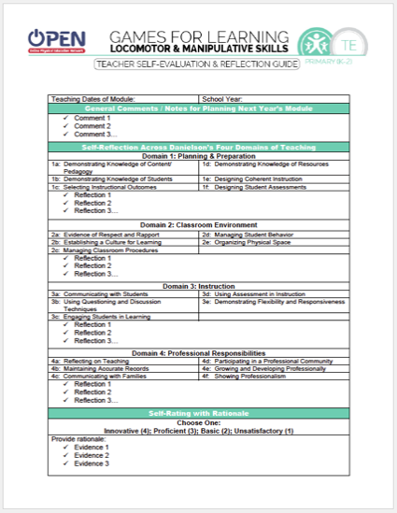
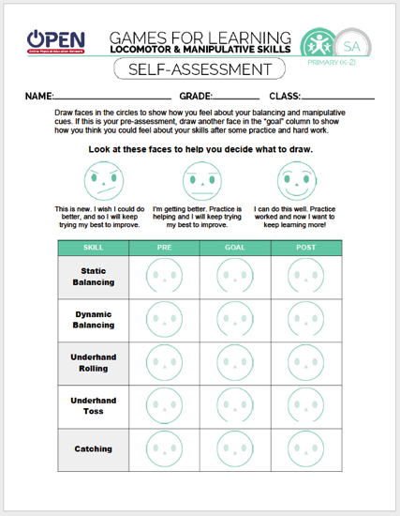

Reflection Guide
OPEN has more than just games…The back page of each activity plan has progressions, modifications, DOK questions, teaching strategies (Marzano), AND MUCH MORE!

Every child deserves an effective physical education program
Every teacher deserves quality physical education curriculum

Please visit www.usgames.com for all of your equipment needs.
Assessment Options

