OPENPHYSED Pickleball

Introduction of OPEN and OPEN Activities
- Aerobic Numbers: Creative Mode Fitness Secondary
- Aerobic Tic -Tac - Toe: Creative Mode Fitness Secondary
- Team RPS: Creative Mode Fitness Secondary

Appendix (Last Page) – Pickleball Rocks check off sheet is used as a self-assessment of each skill.

Drill: Partner Toss Drill - Pair up with a partner within your team. Partner A tosses to Partner B. Partner B hits the ball to Partner A so that A can catch the ball. 10 times. Switch positions.

Drill: One-bounce partner drill- In partners about 30 feet apart, students drop hit the ball to their partner, who let it bounce once before returning. When an error is made begin with a drop hit once again. First use forehands only and then backhands only. Change partners.

Team Challenge: Rally Tally-Partners count how many times a ball may be hit over the net with one bounce. When a ball is hit out, in the net or two bounces begin a new rally.

Team challenge: Backhand madness- Same as above but with backhands only.

Drill: Crosscourt/down the line: Two balls in play at a time. Players on the right side of the court hit down the line to each other and the same on the left. Coach tells them to switch after approximately 1 minute all players will use crosscourt shots. Switch with teammates.

Team Challenge: Fronton Doubles- Begin with each team putting two players on the court against partners from another team. Put ball in play with a drop-hit and play out the point. Team who wins the point stays on the court and receives a point for their SE team. Losing team from the point switch with two teammates. Winning partners stay on until losing a point or winning 3 consecutive points. Play to seven or time limit. Total the score for your team. Rotate teams. Round Robin format. Give points to teams for 1st thru 6th place.
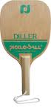
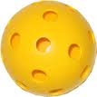
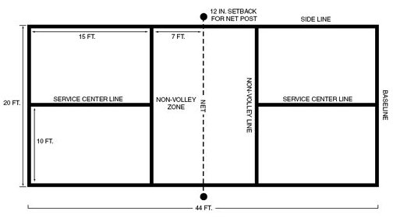
Drill: Fronton singles within teams.

Drill: Partner Rally Drill-Partners face each other over a net. Drop-hit the ball to begin and volley without letting the ball touch the floor. Use both forehand and backhand hits. Attempt to volley 10 times consecutively. Count how many times you can keep the ball in play.

Drill: Partner One-Bounce and Volley Drill- Stand 30 feet apart and mix volleys and one-bounce shots, using forehand, backhand, underhand, and overhand hits. (8-10 min.)

Drill: Partner One-Bounce and Lob drill- Partner A drop hits to partner B who lobs the ball using forehand or backhand lob. Return shot from partner A is a one bounce hit. Continue with one-bounce to lob. Switch roles (5 min.)

Drill: Serving Drill: A serves 3 balls from the right court across to D. Player A goes to the back of the line behind C. C serves 3 balls diagonally from the left court to B. B and D retrieve the balls then serve 3 balls back across diagonally and go to the back of the opposite lines.
D
B
C
A

Drill: Serve and Lob drill- Two pairs of students to a court. A and C serve to B and D. B and D allow one bounce and lob the ball back to A and C. Serve 3 balls then rotate.

OPENPHYSED.org Secondary Badminton

- King/Queen of the Court
- Move and Clear

Drill: Serve and Return Game: Team Challenge: Teams play against each other. Keeping the same formation, the receiver stands inside the diagonal court and returns the serve after the ball bounces once. Alternate serving sides after every serve. Teams score 1 point for every legal serve and 1 point for every legal return, meaning that the ball must fall within court boundaries. Players rotate serving and receiving after each attempt. Players not engaged in the point should retrieve balls and assist in keeping the score. Server calls out the score. Play to 11 points or to time-limit. Play a round robin using this serving point game for team points.

Drill: Have partner 1 toss the ball and partner 2 smash the ball (switch roles) Partner 1 will stand on outside of the court and partner 2 will be on the other side on the non-volley line
– Partner 1 - Partner 2

* Same drill as above except the feeds are a lob from the baseline.

Team Challenge: Target smash drill. Set up cones and/or hoops Players 5 feed balls to teammates who try to hit the targets. Specify amount of points for each target. Total the score for each player. Team gets a total for all scores and report to the statistician who will record the scores.

Team Game: Game play within your team for the remaining time. Anytime a player successfully hits an overhead smash it is 3 additional points.

Drill: Player A drop hits a ball deep to forehand of B, B returns, A attempts to move B short or side to side on the next shot.

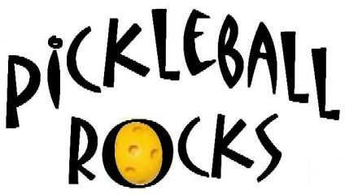

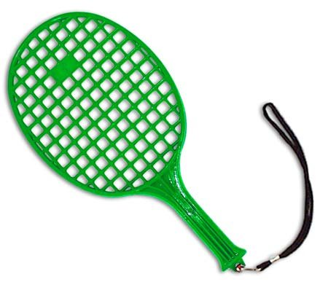

Assessment #1 Team name _________________
Ball Handling
Directions: Each student must write their name in the names column. Next, each student must perform each of the six tasks and write how many times/how many seconds you were able to perform the skill. Please be honest when recording your score. Fair play points will be rewarded for each team completing the assessment.

Student Names | Balance Ball on Paddle while walking (30 sec) | Palms Up  (25 x) | Palms Down (25 in row) | Alternating Palms up and down (20 in row) | Drop-hit ball up to self on paddle (5x) | Wall rally  (20 times)

