Sport Education: A Teaching Model That Never Grows Old!
(Sport Education Model may be used for fitness, lifetime or team units.)

Speedball: invasion game.
Speedball Equipment: cones, soccer balls (Indoor or outdoor) dome cones, hand held whistles, jerseys

Instructional Objectives:

Students will demonstrate the ability to perform the proper use of various passes while creating space to maintain possession of the ball.

Students will use their knowledge of trajectory and force to be able to execute 5 quick; short passes in order not to get intercepted by the opponent.

Students will play speedball under the modified rules exhibiting acceptable levels of personal and social responsibility.

Embedded outcomes:
- Responds appropriately to participants’ ethical and unethical behavior during physical activity by using rules and guidelines for resolving conflicts. (S4.M4.8)
- Cooperates with multiple classmates on problem-solving initiatives. (S4.M5.8)

Grand Prix Relay Race
Players: 1-10 per deck Time: 3-10 minutes
• Objective: Finish the most cards or do the exercises as perfect as possible.
• Setup: 1 deck per team, no more than 10 people per team, put the exercises in facedown piles for upper, core, lower. The teams line up facing the exercise piles, 10 feet away.
•Gameplay: The first person runs to grab a card from any of their team’s piles. Bring the card back to your team; tell them what the exercise is, and the team completes10 reps of the exercise together, counting out loud. Play until time expires or one team finishes all their cards.

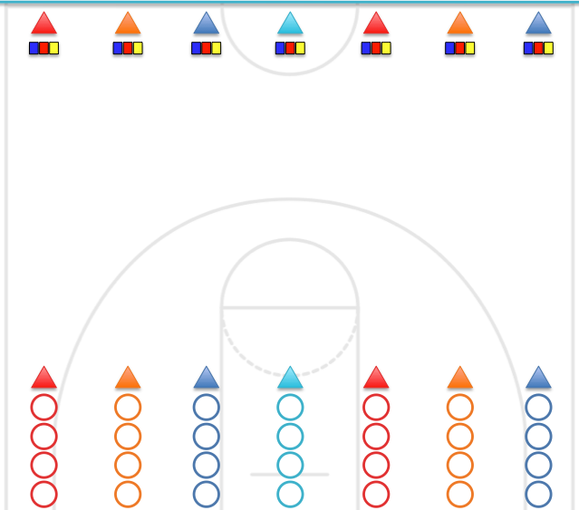

Sport Education Sample Lesson Day 1

Power point Sport Education

- Choose team name and mascot. (Report these to commissioner (teacher) for approval) Captains get a team folder. Assign color and number. Place on folder.

- Assign roles for the team. Fill out role sheet. Assign according to what is needed for this season and number of players on a team.
Roles: Captain, Coach, Manager, Exercise Specialist, Publicist, Motivator, Head Official, Head Statistician, Sports Council. (Any roles needed for the sport season)

- Begin making team poster: Team name, mascot, names of players (roles and something they like to do)

- Tasks to be completed:
- Captain: Team read and sign contracts (10 points)
- Exercise specialist makes up the warm up using a variety of Health and Skill related activities. Pedometers issued to each team.
- Coach: plan a team warm up 5 minutes with equipment.
- Captain: Review rules/history with team.
- Motivator: Make team cheer.
- Put poster on the wall when complete. May work on these again at the beginning of class day 2.

- At the whistle warm up (exercises) as a team (Possible 10 points)

- Next whistle go to your assigned court.
- Manager gets the equipment and jerseys for your team.
- Warm up with equipment. Led by coach. (Possible 10 points)

***Team points deducted for conduct violations during warm-ups, practices and games. Plus points for positive behavior. ***

Note: In this Sport Education Season:
- __________ teams
- ______________members of each team play at one time.
- If a team has more than ___________ players, the team members take turns substituting. Everyone must be a substitute.
- If a team has less than __________ players on a given day, the team plays short handed.

Lesson Day 2: Maintaining Possession of the Ball

Read the white board when entering the gym*
Whiteboard: All students read the whiteboard at the beginning of class.
Managers: Get jerseys. Captains: Get folder and pencil. Take team to home grid. Exercise specialists make sure you have what you need for warm-up. Coach: Make sure your team warm-up is ready. Motivator: Review cheer.

Pre-Season Practice: Coaches Plan

Instant Activity: Practice with your team using one foot and two foot self-air passes.
Team fitness warm-ups: Exercise specialist will lead warm ups he/she has prepared for today using health related components.
Decoder Activity: Team Competition
Passing and Communication Drills

Goal: In an effort to get students passing and receiving with confidence, WE will be using a series of warm-up activities and lead-ups that help students better communicate and practice these skills. Emphasis will also be pleased on “moving off the ball” and throwing with tracking, torque, and follow through technique.
Warm-up: Star Passing: Common 5 player formation in which the person throwing the ball must throw to a person across from them, but not on either side. The following person does the same until a star formation is created. Different forms of throws can be used (underhand, overhand bounce pass…etc.), as well as different catches…two hands, one hand, claw grab. Multiple balls can be added after students perfect pattern…then multiple objects (ex. football, soccer ball, hacky sacs, etc.). Speed up, complete on whom does not drop an object or rotation of objects all around.
Lead-in: Circle Passing Drill: Students form two circles of evenly spaced people. 2 students go to the middle with one ball. Student passing the ball follows the ball and prepares for future receiving this pass and move rotation goes all around the circle with new players coming to the middle each time to receive the ball. Competition can be timed on how fast the ball is rotated through the whole group back to the starting point or between two circles to see who can get through it the fastest. Two more go to the middle (4 total) and same passing pattern is used again with 2 balls being used at one time. Advanced- Add another ball with this being the 3rd ball (6 players in the middle or even 4 balls, 8 players in the middle).

Team vs. Team: Catch Game of 3’s in Grids
- The object is to complete 3 consecutive passes without dropping the ball or having it intercepted.
- If 3 catches are completed, 1 point is awarded and the other group takes the ball.
- If the ball is intercepted or deflected, the defense takes possession at that spot. Count your catches out loud.
- May not move when in possession of the ball, only a pivot.
- May only hold the ball 5 seconds.
- Statistician record points won for your team.

Peer Assessment and Review of passes from prior season of basketball
- Two teams join together. Place each group at a poly spot/cone facing each other.
- Team A XXXXXX xxxxxxx Team B
(Captain) (Captain)
- Team A pass to team B. Team A will then go to the back of the line of Team B.
- Team B will catch the ball then pass to Team A and go behind.
*Captain assesses their team on passes.

Skill Drill: Team Practice: 2 vs. 1
- Each group will have a defender and two attackers who will try to maintain possession of the ball using the underhand, overhand or chest passes.
- Three players. Receiver is moving
- Thrower chooses when to throw. (Use pivot/Fake) Do not throw over the marker; throw around them. Marker must give the thrower space.
- Switch positions. After a few throws. Variation: Add a stall count and also add a marker on the receiver.

Throw-and-Go Drill
- Players make two lines single file facing each other. 15 yards apart.
- First player in line A and B do not have a ball, but the next four players do.
- First person in line A runs hard at a 45-degree angle toward line B. He is running to receive a backhand. He makes the catch and runs to the back of line B handing the ball to the next person in line who needs a disc.
- If the disc is dropped it is retrieved and goes to the back of the line.
- The drill continues in this manner with each player having at least 10 chances to throw and catch a pass.
Variations:
- Throwers use a pivot and then a pump fake to the opposite side before making the proper throw.
- Receivers catch with only one hand or their non-dominant hand.
- Add a marker to both lines to increase the difficulty of the throws, making the drill even more realistic.

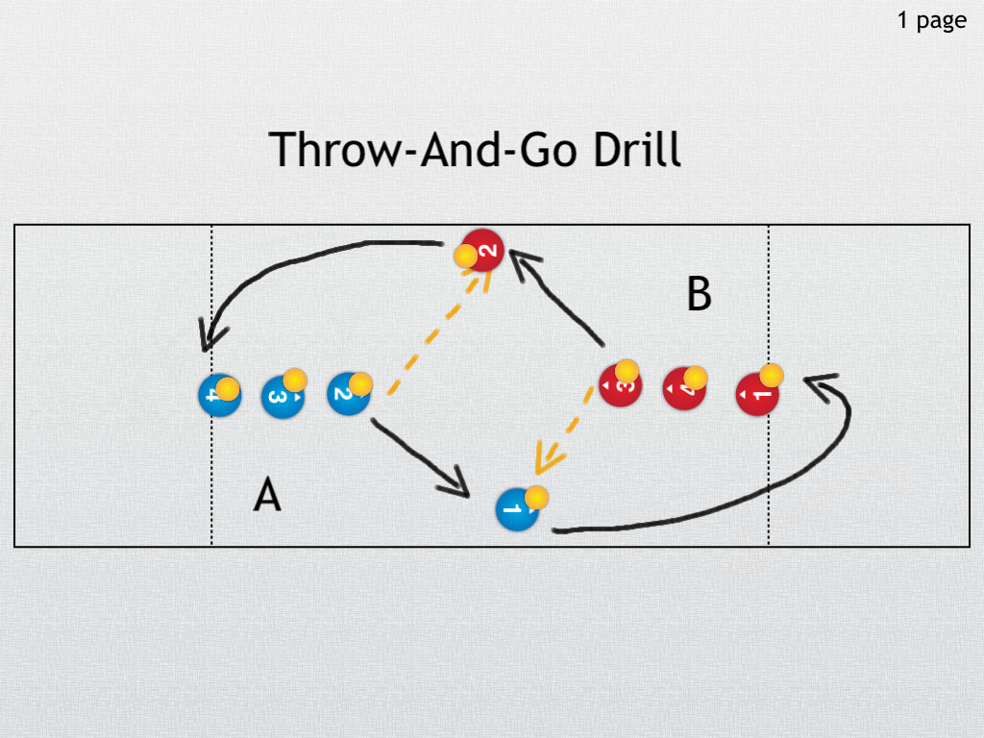

Round Robin Pre-Season Points
Modified Game:
Objective: Make accurate and firm short passes and support the ball carrier.
Initial Game: Set up a field with boundaries and a halfway marker. Each team member must complete a pass to a teammate while playing against an active defense. In order to score every team member must complete a pass and they must cross the centerline. Each team can only use a passing technique indicated by the teacher (e.g. under hand pass, over hand pass, or chest pass). 1st 2-3 minutes only underhand passes. 2nd 2-3 minutes only over hand passes and 2-3 minutes only chest passes. Once a team completes a pass to every teammate using the specific pass indicated by the teacher and crosses the centerline; then the official will reward 1 point to that team.
Goal:
  - Use a variety of accurate passes using all prescribed types.
  - Players move to get open using the entire field to receive a pass.
  - Players execute quick and short passes in order not to get intercepted.
Closing game- Speedball
Play game of Speedball adding the rule of 5 consecutive passes in a row = 1 point.
A few reminders: In speedball, you may convert from a ground ball to aerial ball. Once the ball is converted to an aerial ball, one self-“air dribble” is permitted before passing to another player.
When receiving an aerial pass on the move, you are permitted two steps before passing to a teammate. The ball may be dribbled and passed on the ground like in soccer.
Change of possessions occurs when: The ball touches the ground. The ball goes out of bounds. A team uses an illegal pass. A team scores a point.
Scoring for today: Soccer goal= 2 points Pass= 1 point 5 passes cons. =1 point

*This is a wonderfully adaptable game. In addition to playing either indoors or out, teachers and students can vary the scoring methods and points, length of game, number of players, size of field/court

Speedball – The Game

Description:
Speedball is an invasion game that combines the skills used in basketball, football, and soccer. Traditionally played outdoors on a soccer field, the game can be modified for indoor play on a basketball court. The object of the game is for a team of eleven players (outdoor version) to move the ball (soccer ball) down field into the opposing team’s territory and score a goal in one of three different ways. The ball may be kicked into a soccer goal, drop kicked through ‘goal posts’ or passed into the end zone. When played indoors, the drop kick through goal posts is replaced by shooting the ball into the basket on a basketball court. (Optional)

Background and Basic Rules of Play:
E.D. Mitchell at the University of Michigan initially developed the game in the early 1920’s as an activity that all students could play regardless of their athletic experience. In speedball, the ball can be played in the air (similar to passing in basketball or football) or on the ground as in soccer. A ball caught in the air off the foot of another player or by converting the ball from the ground to the air by oneself is played in the air until or unless the ball touches the ground. Once the ball touches the ground, all soccer skills apply to moving the ball. Play starts with a jump ball (as in basketball). The jump ball is also used to put the ball back into play following offsetting penalties, if the ball is ‘tied up’ between two opposing players, or the official cannot determine who gets the ball. After a score, the opposing team gets the ball at half field or half court for a kick off, similar to soccer. The game is played in four quarters, similar to basketball. Each quarter can be up to 12 minutes long.

Moving the ball
A player may dribble a ground ball with the feet as in soccer. Once the ball is converted to an aerial ball, a player may use one ‘air dribble’ to self before passing to another player. When catching an aerial pass on the move, a player may take two steps before passing to a teammate. There is typically a time limit for possession of an aerial ball before passing or shooting (e.g. 3 seconds).

Scoring (optional)
Typical scoring methods when playing outdoors are as follows:
• Field goal – 3 points
• Dropkick – 2 points
• Touchdown – 1 point.

However, the scoring can be adjusted to suit the players and playing conditions. For example, when playing indoors, the number of players per team would be reduced to five or six and the drop kick would be replaced by a set shot or lay-up.

