Ultimate Frisbee Teacher Game Assessment

Players | Moves to get open | Passes to more than one person | Communicates with other players | Makes positive comments | Works well with teammates

1=Never 2= Sometimes 3=Always
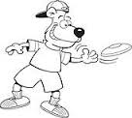

Players | Moves to get open | Passes to more than one person | Communicates with other players | Makes positive comments | Works well with teammates
1=Never 2= Sometimes 3=Always

