Ultimate Frisbee Strategy Assessment

Team Name: ___________________________________________

Player Name | What is the player doing well (offense) | What improvements are needed? | What is the player doing well (defense) | What improvements are needed?

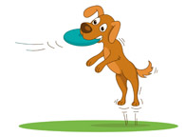
Team Name: ___________________________________________

Player Name | What is the player doing well offensively? | What improvements are needed? | What is the player doing well defensively? | What improvements are needed?

